Database System Engineering and Distributed Backend Development
Course Code: 25CS1302E
Skill Session 4&5

Name: V. Charishma
Roll no: 2520030140
INSERT CUSTOMER DATA
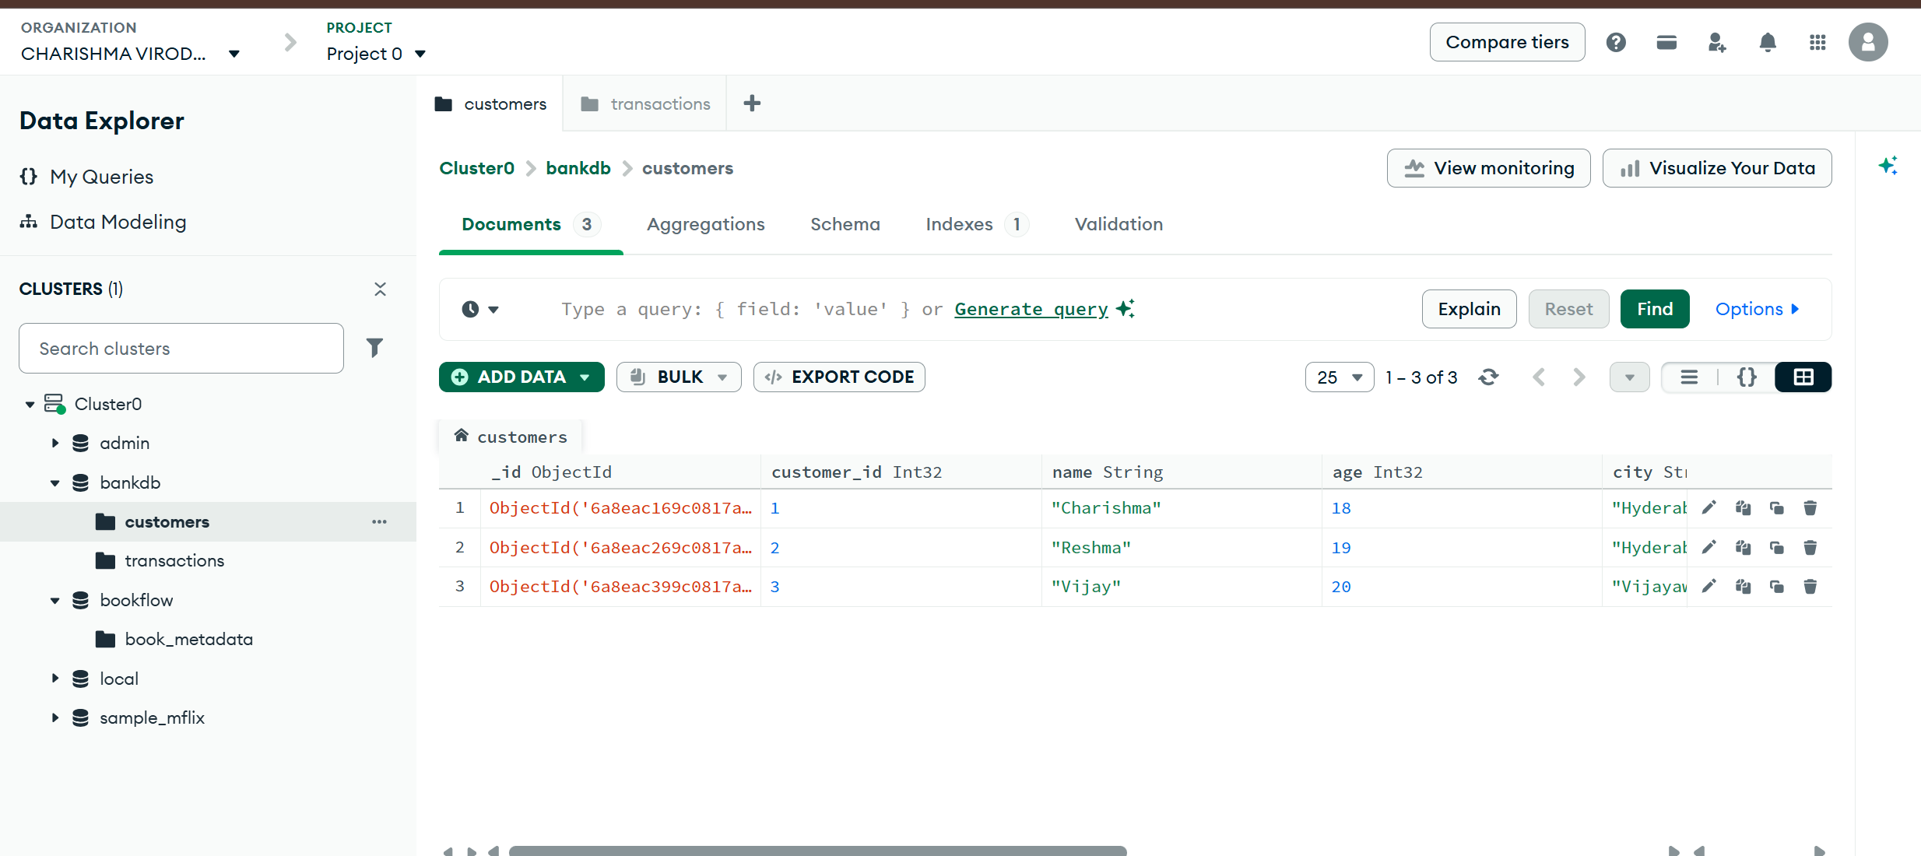

INSERT TRANSACTION DATA
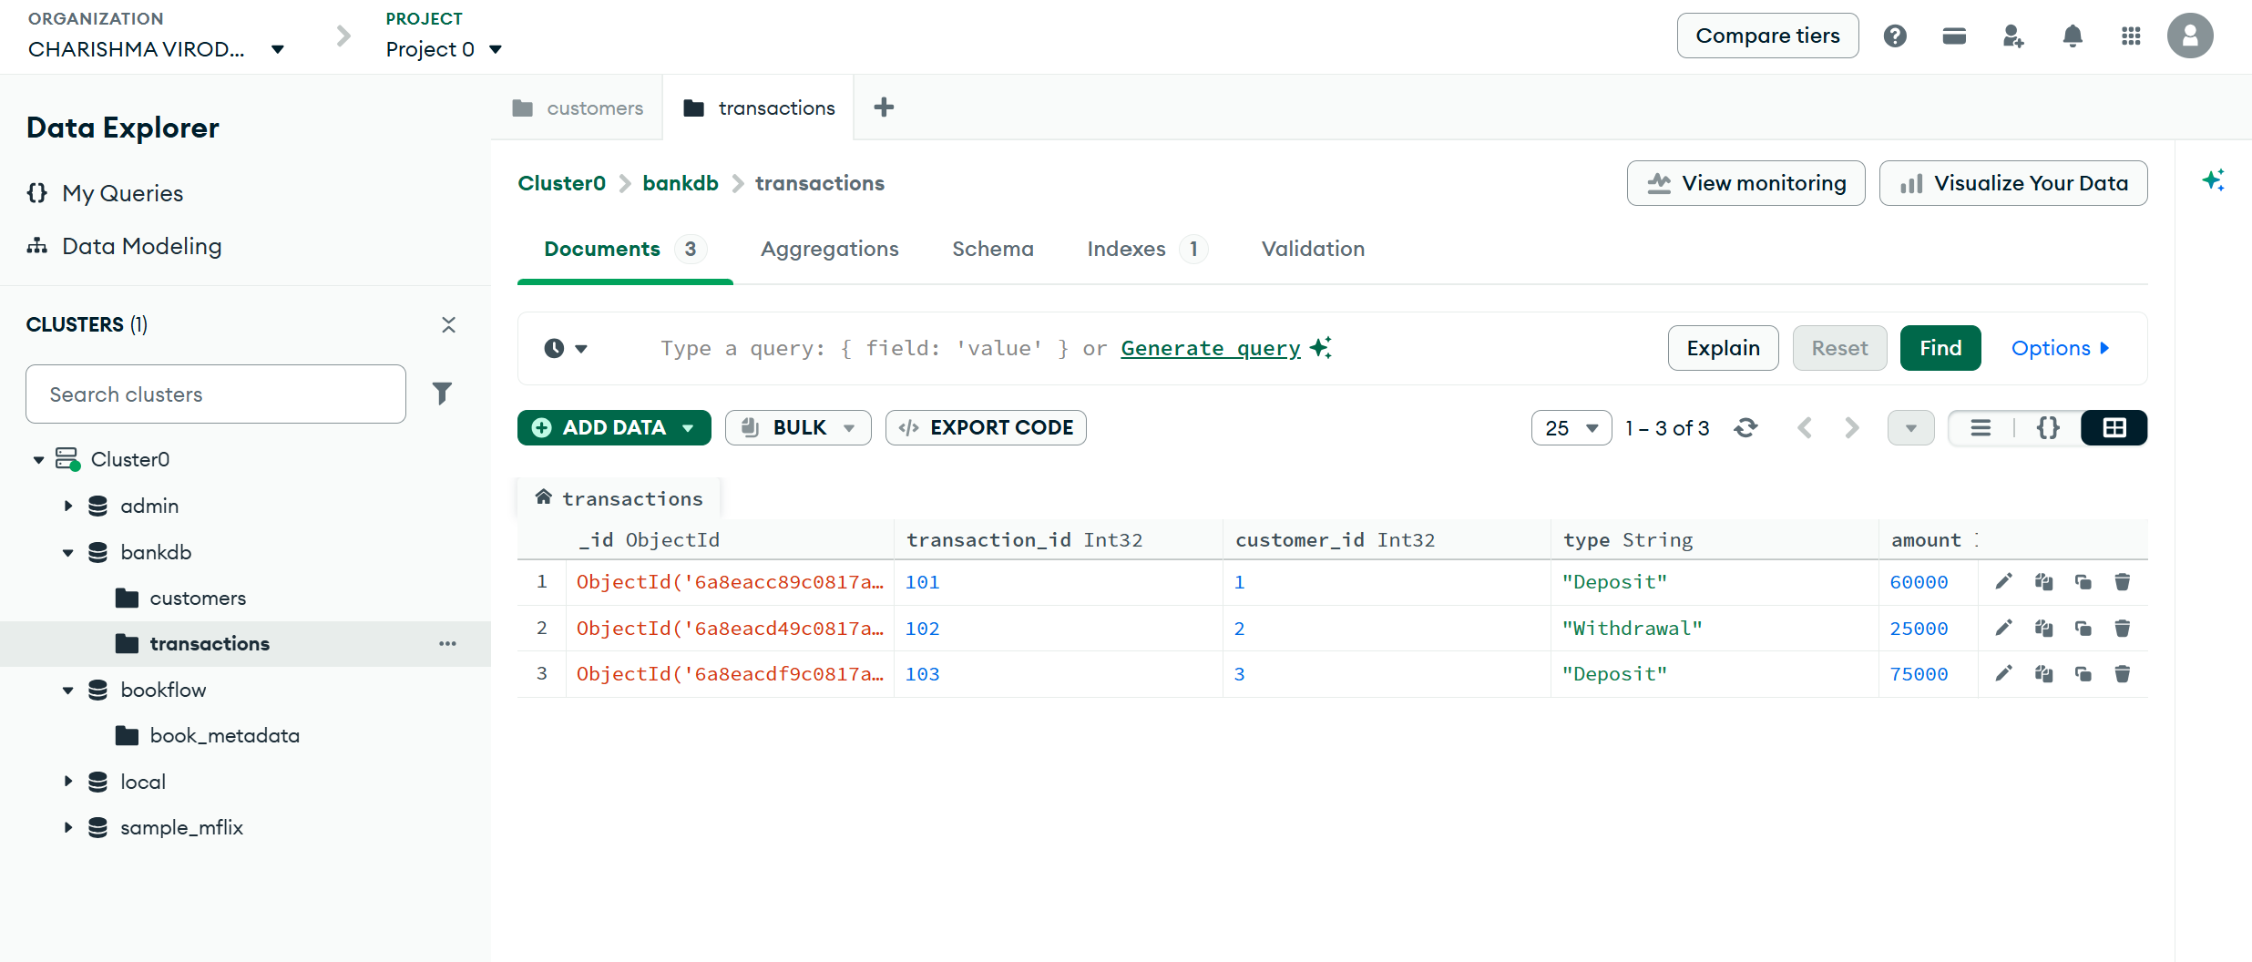
FIND ACTIVE CUSTOMERS
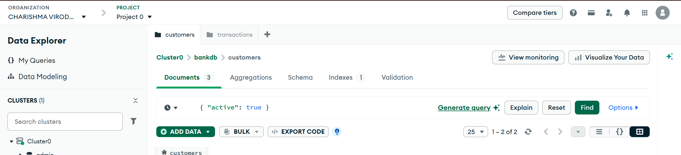
Output:
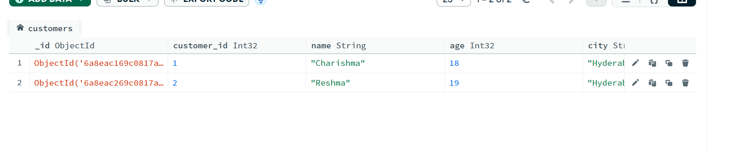
FIND CUSTOMERS WITH BALANCE GREATER THAN 100000
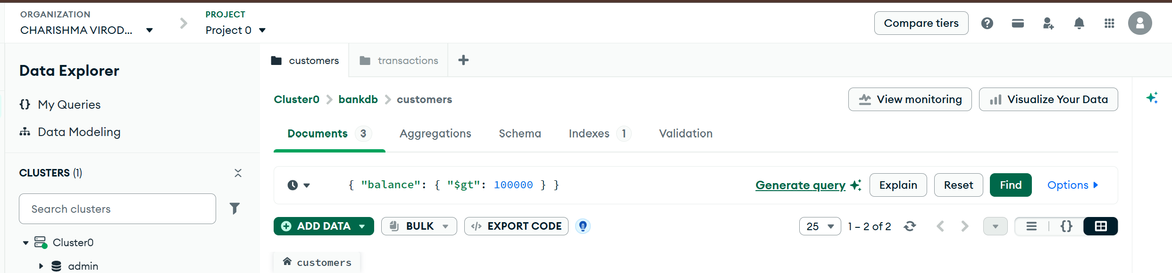
Output:
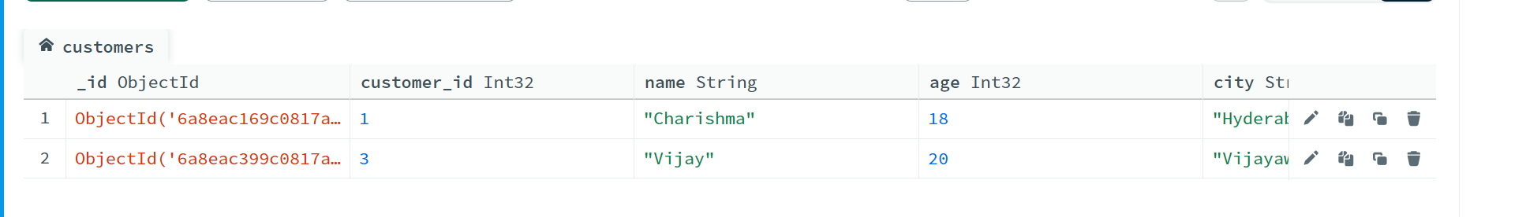

FIND HYDERABAD CUSTOMERS
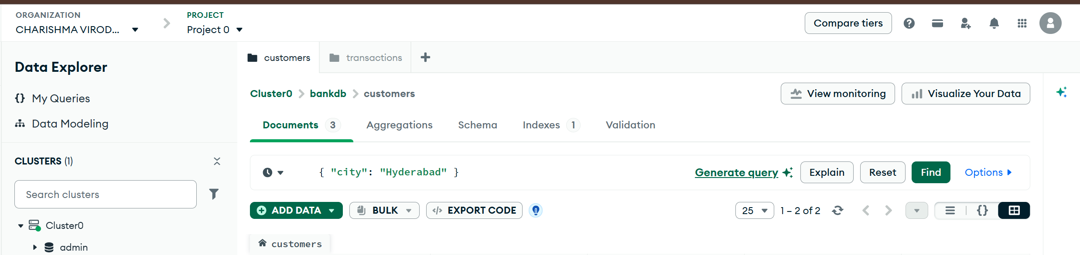
Output
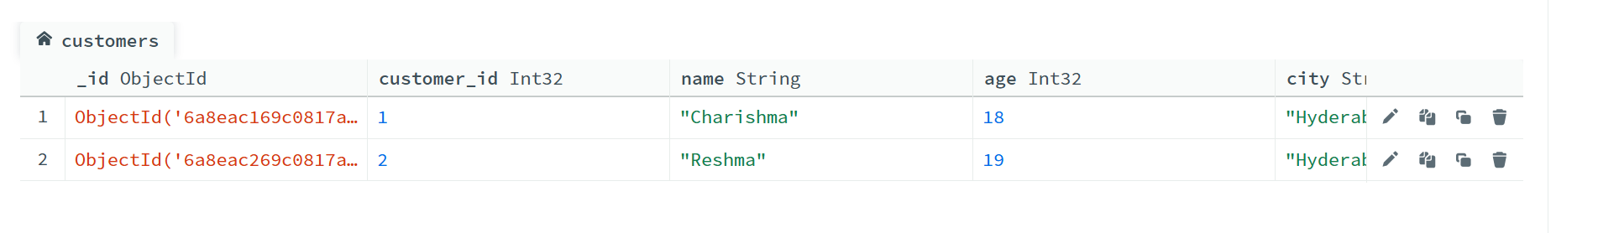
FIND SAVINGS ACCOUNT CUSTOMERS
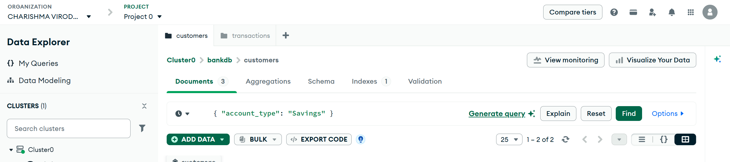
Output
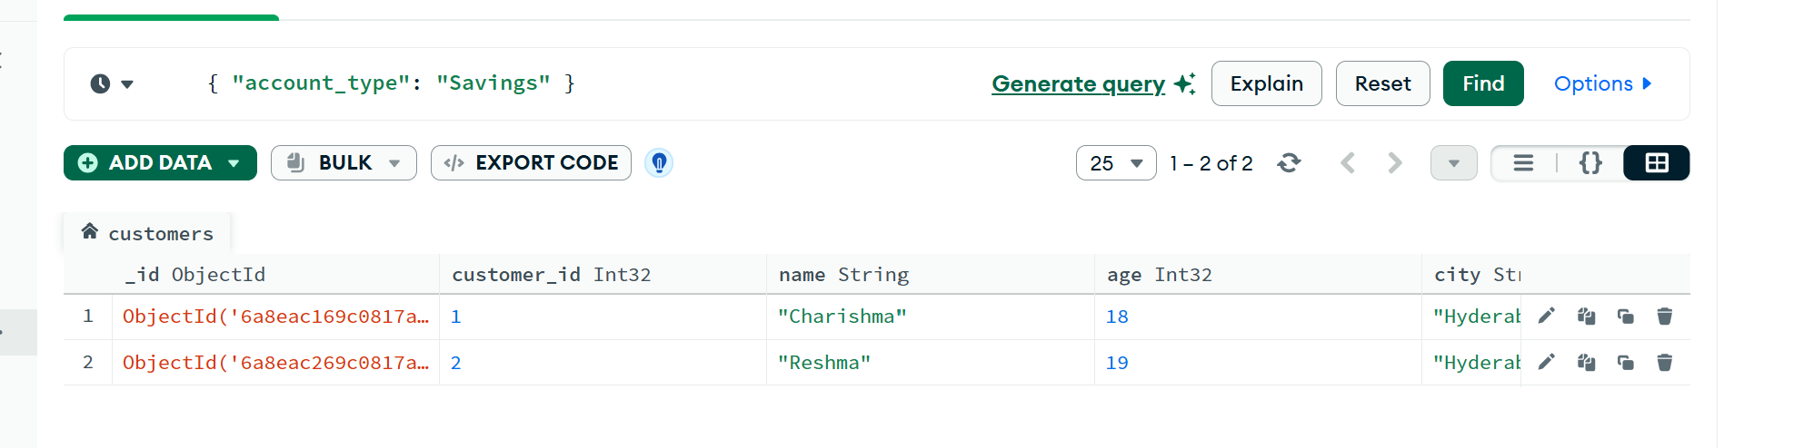
FIND TRANSACTIONS GREATER THAN 20000
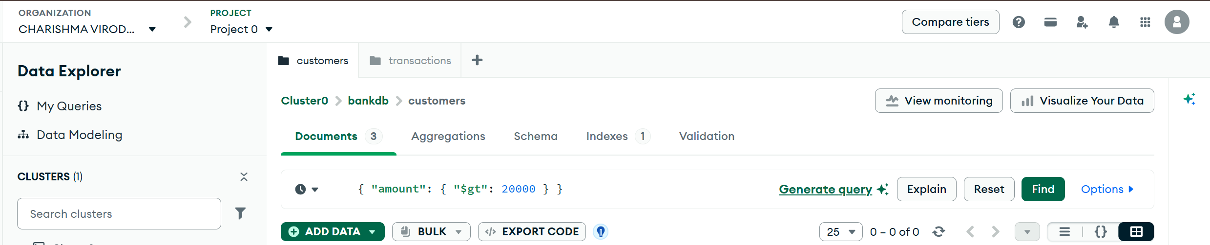
Output
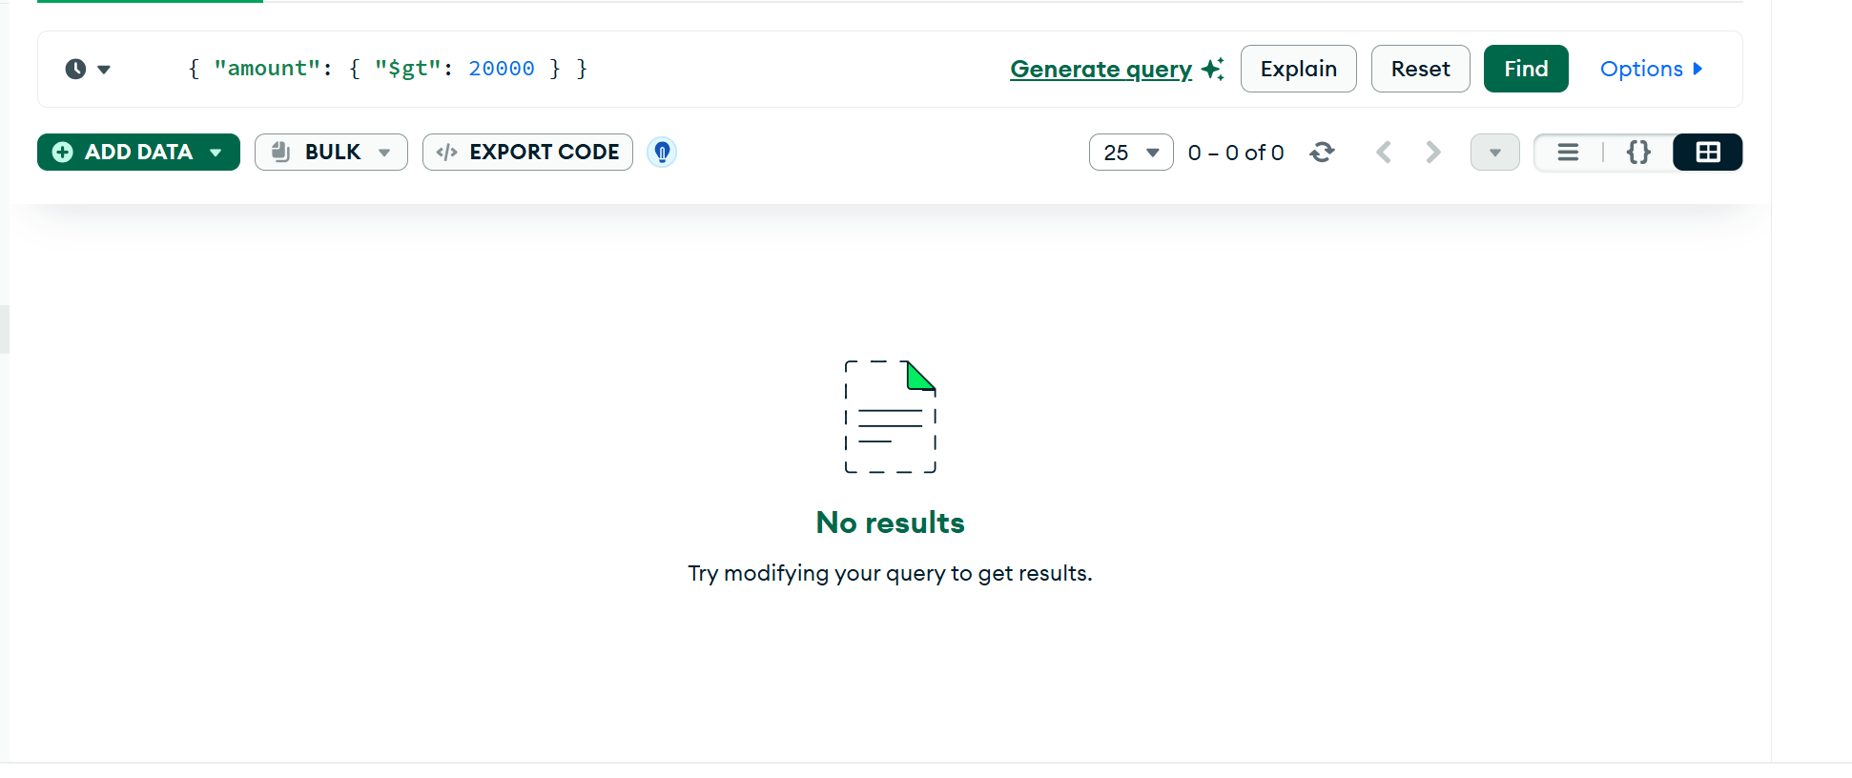
FIND DEPOSITS
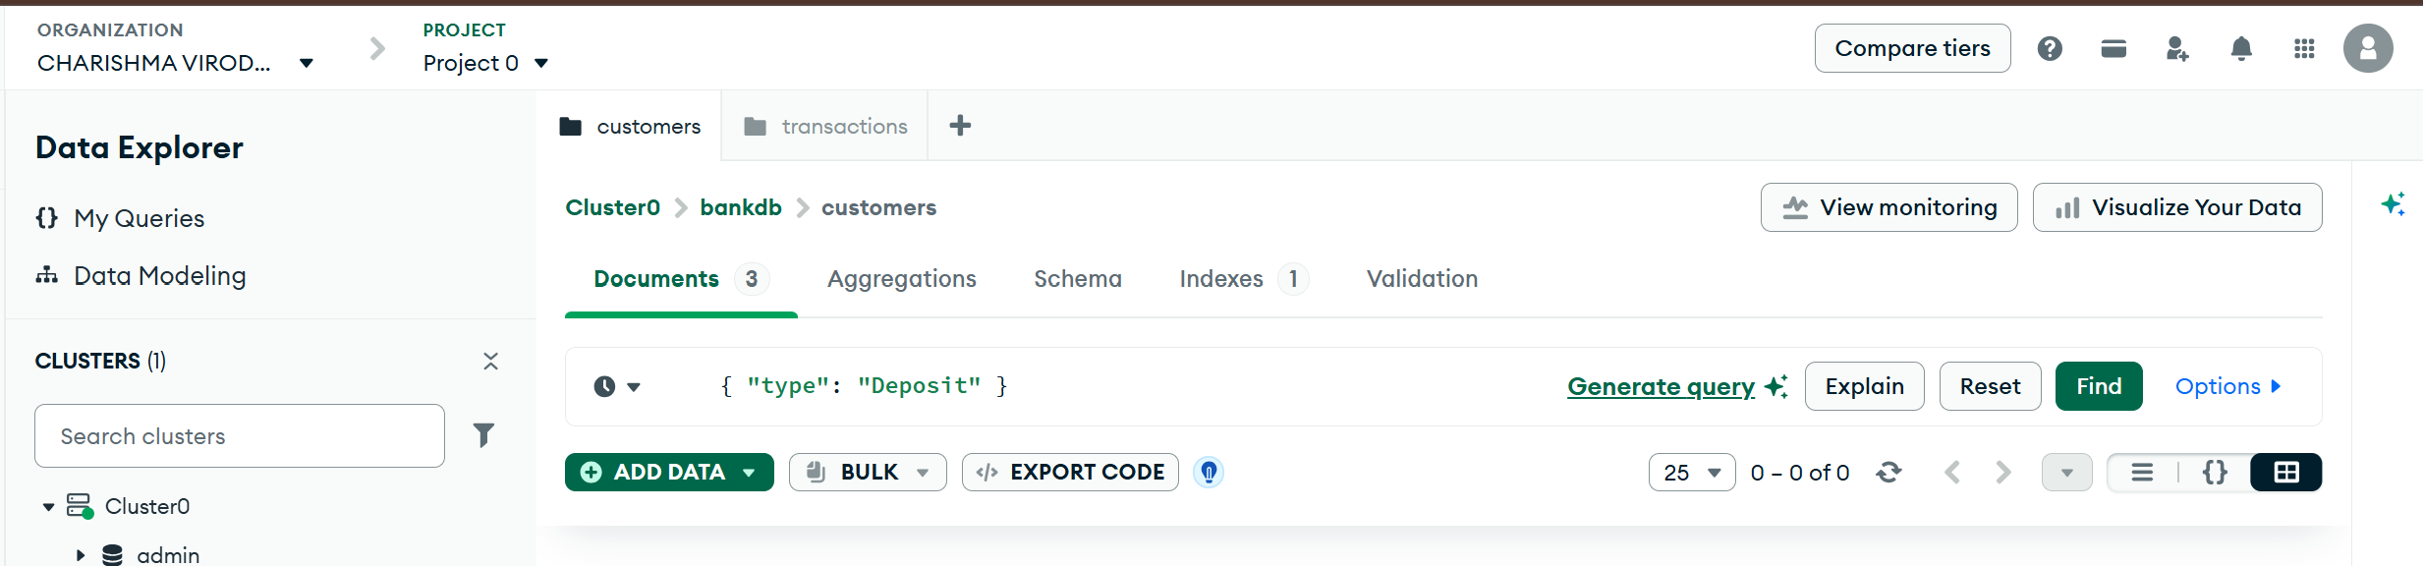
Output
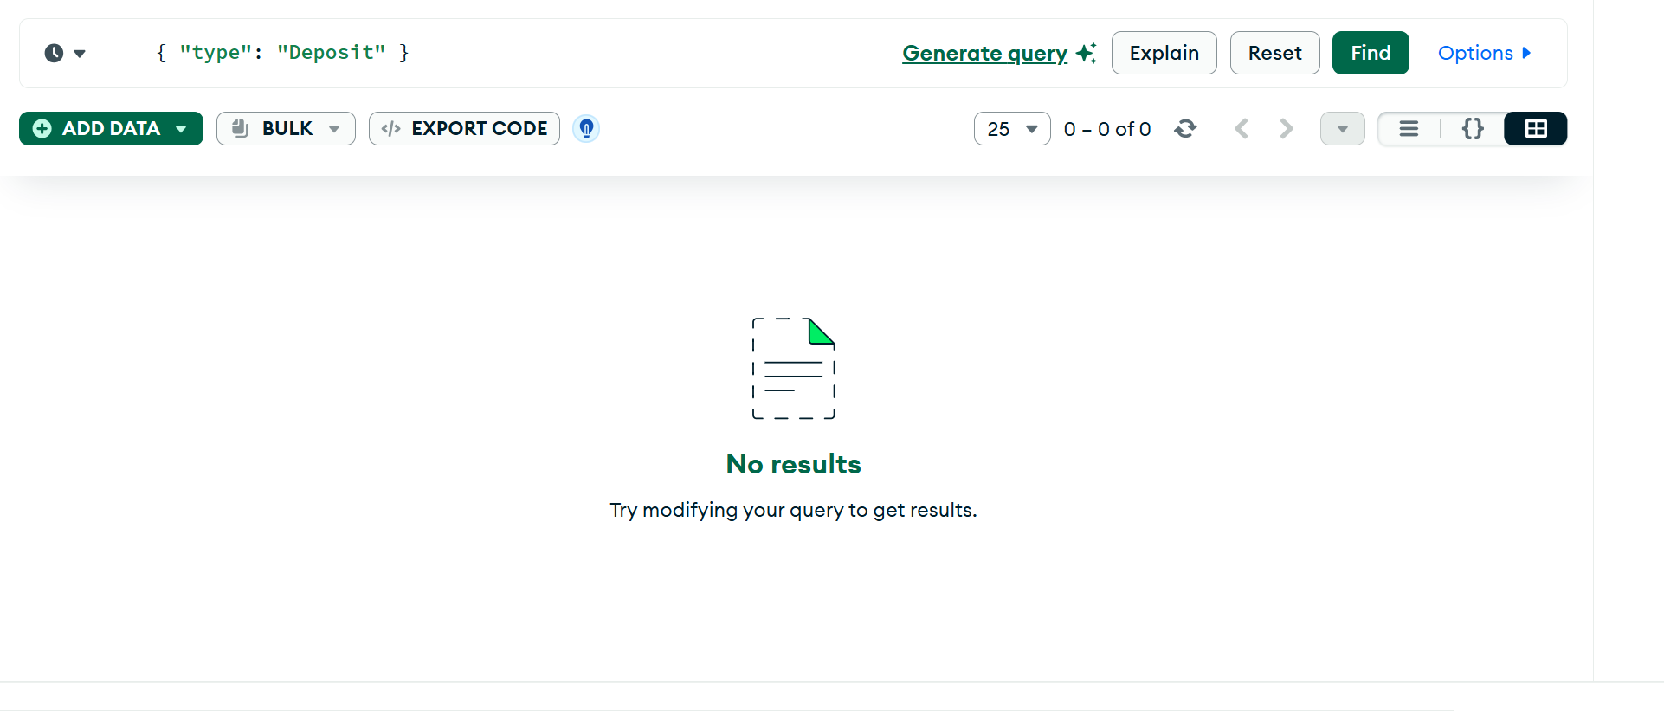
FIND ATM TRANSACTIONS
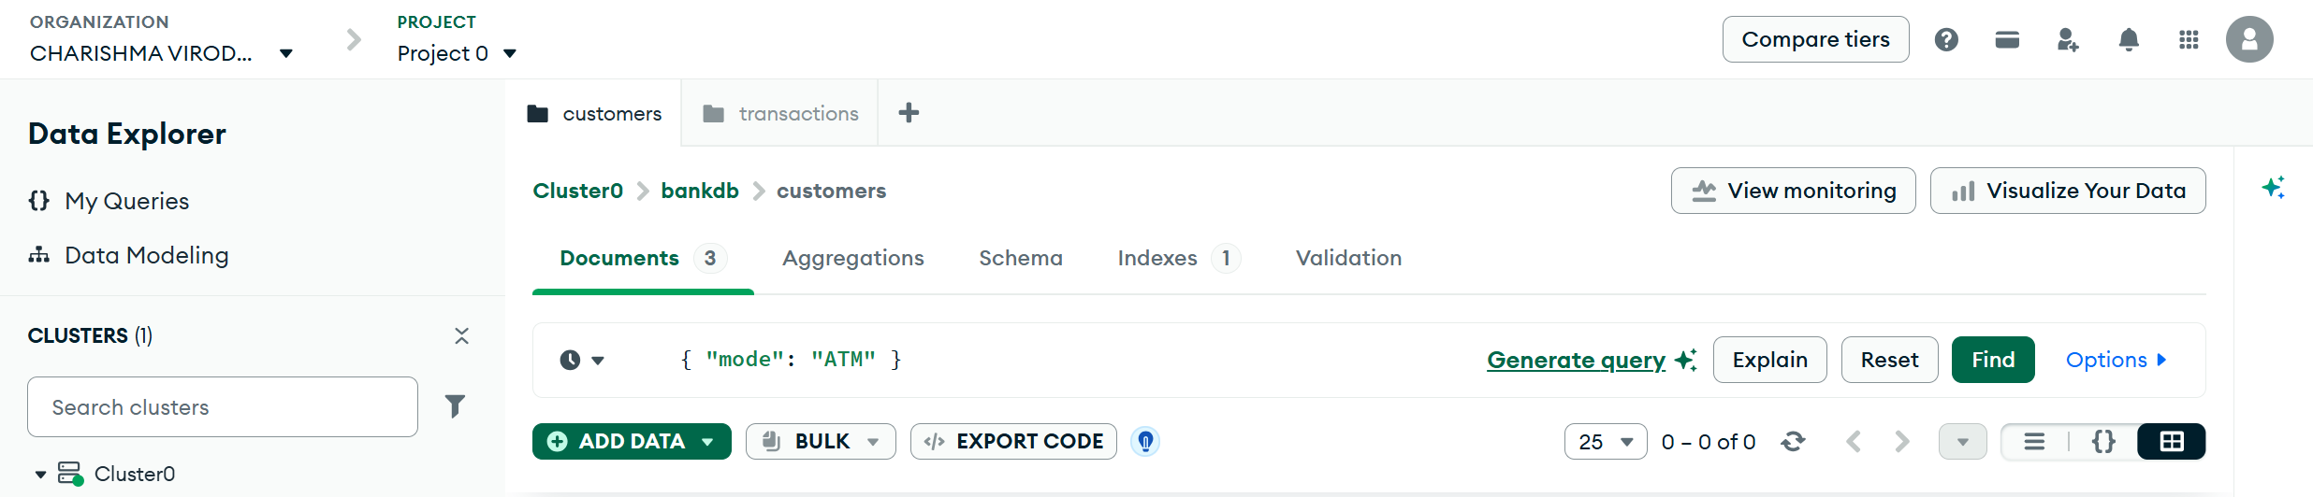
Output
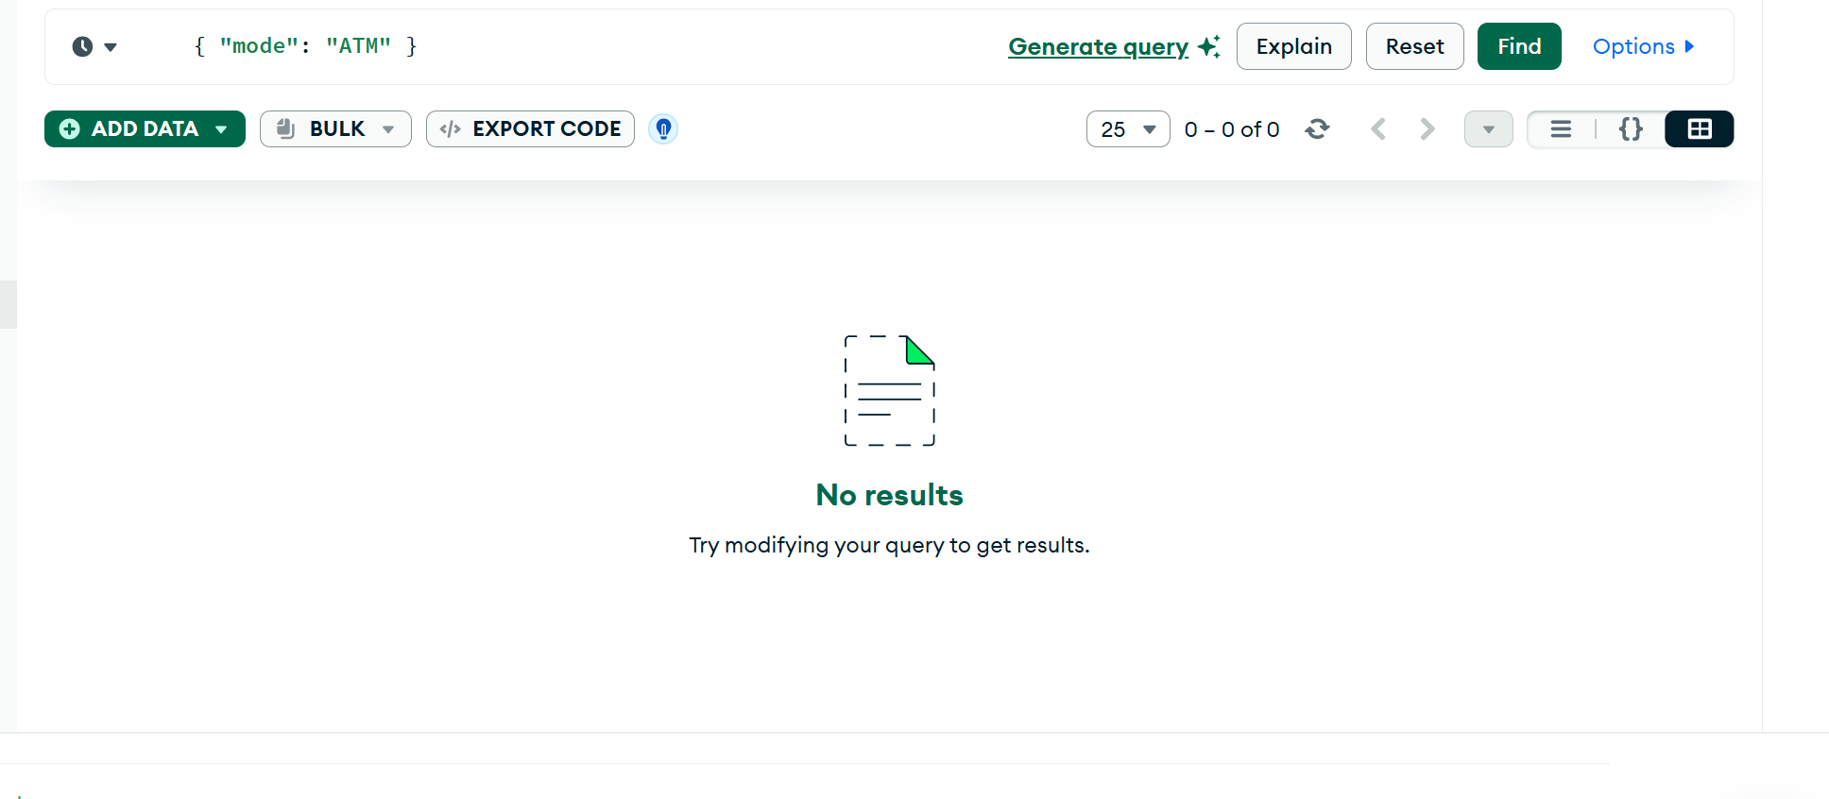
FIND DEPOSITS GREATER THAN 50000
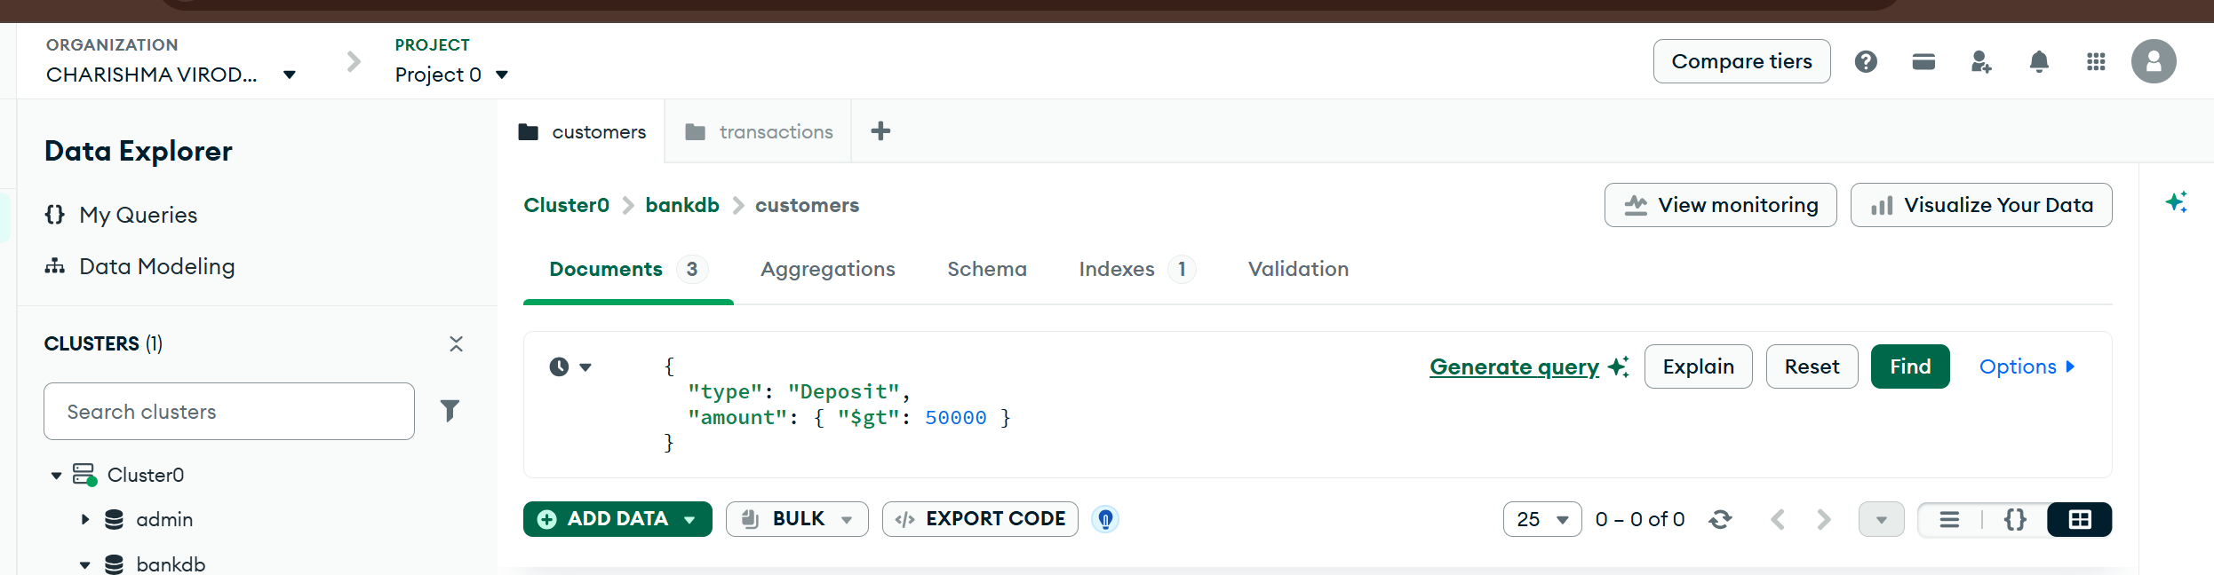
Output
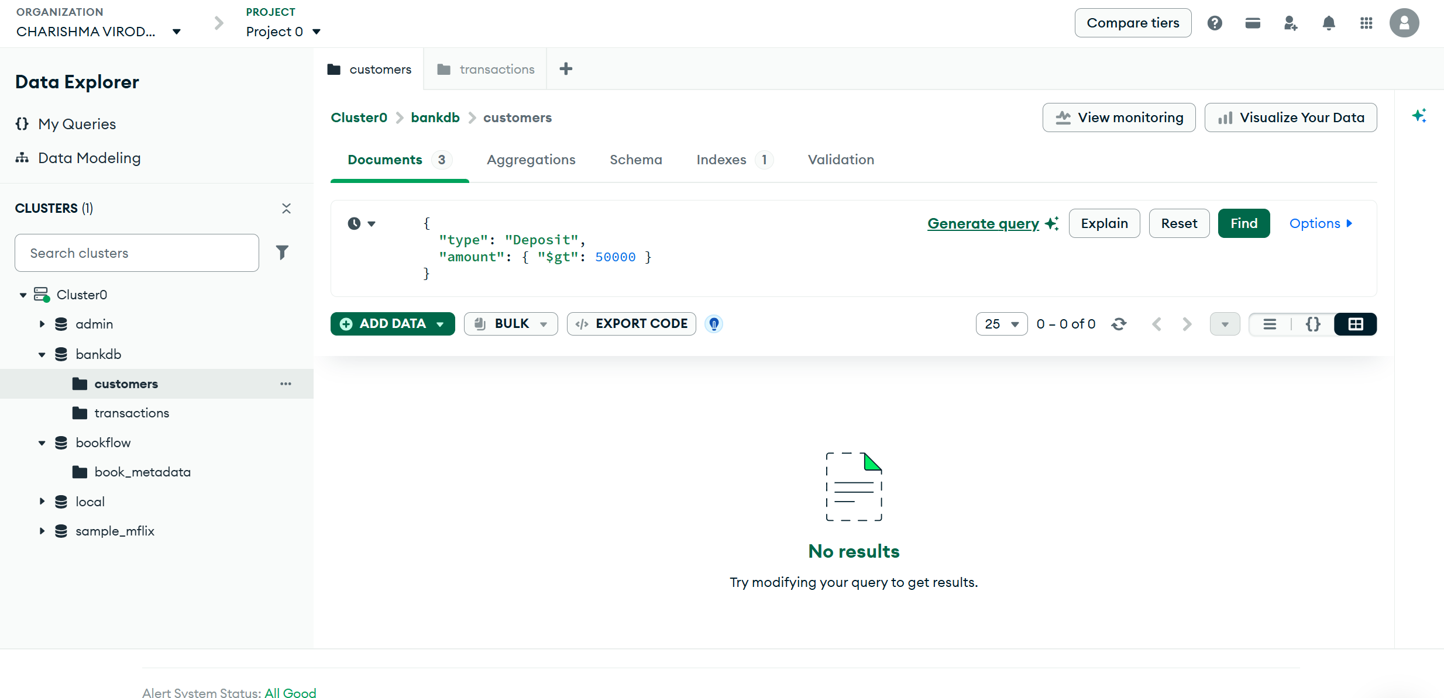
FIND HYDERABAD CUSTOMERS WITH HIGH BALANCE
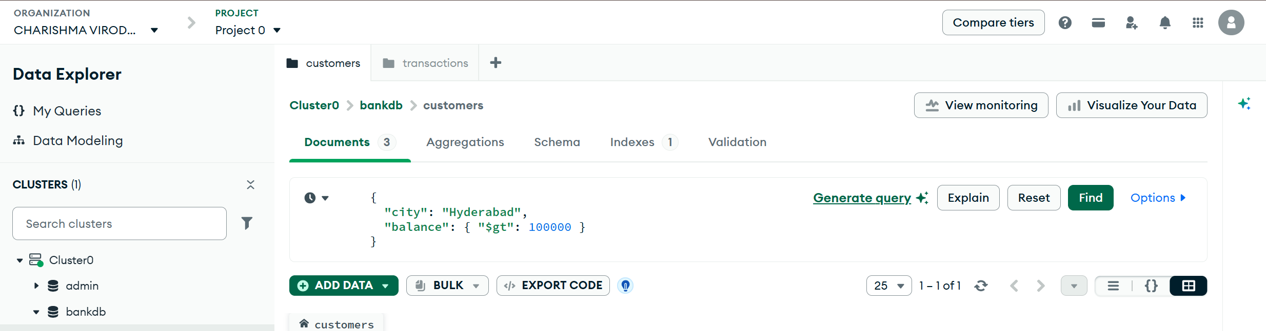
Output
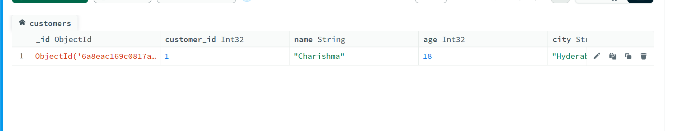
FIND CUSTOMERS IN MULTIPLE CITIES
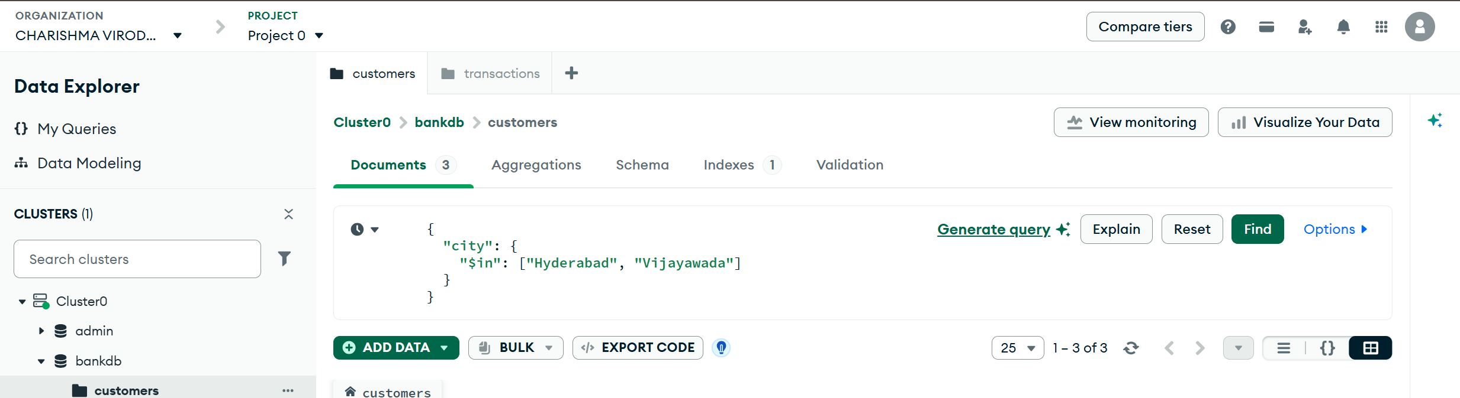
Output
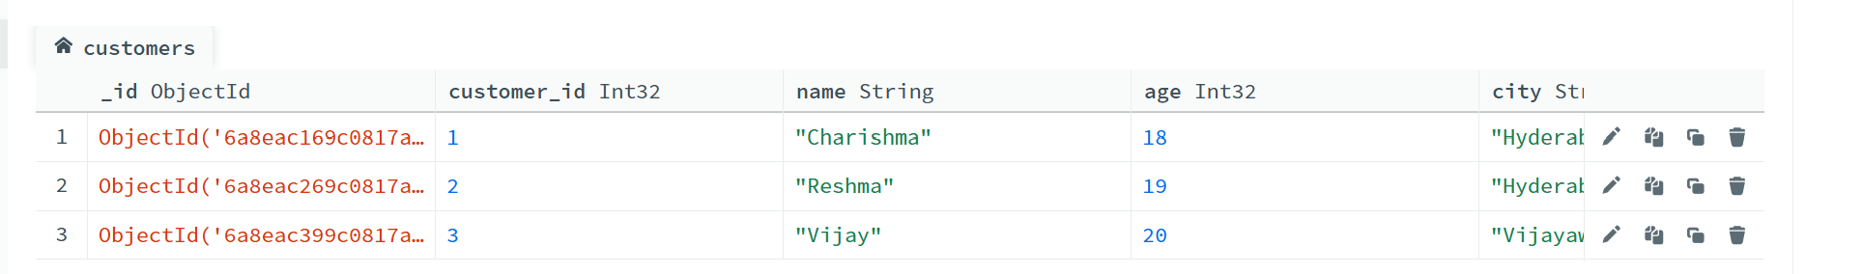
SORT CUSTOMERS BY BALANCE
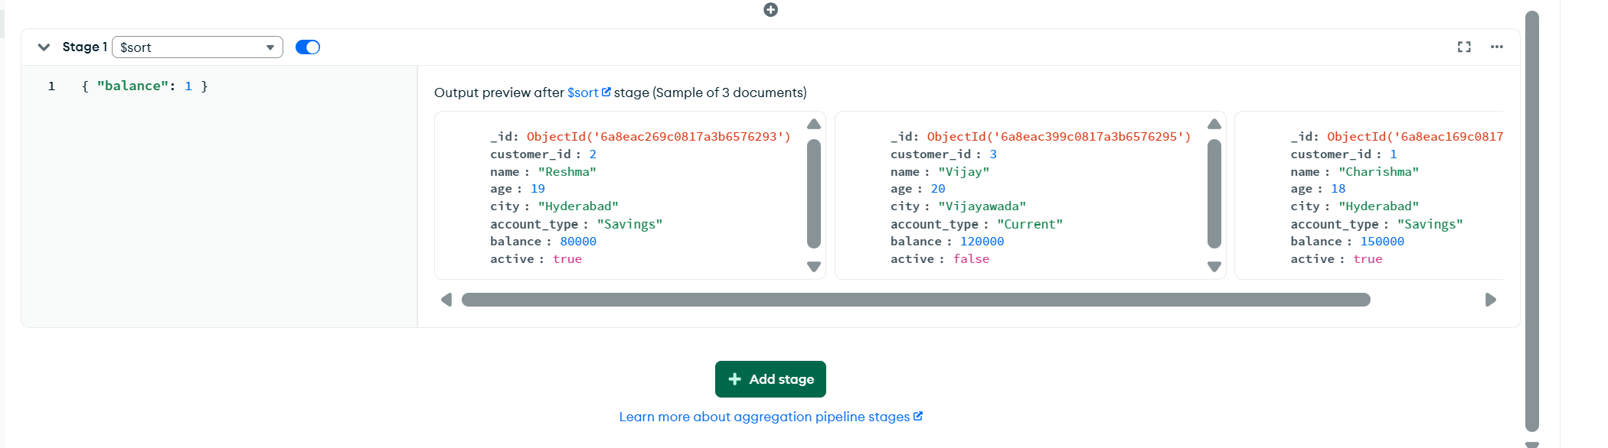
CALCULATE TOTAL TRANSACTION AMOUNT
